(Approx. 84 words)

Disabling a Touchpad in Windows 10
By Leti Labell, Potomac Area Technology and Computer Society
September 2016 issue, PATACS Posts
www.patacs.org

editor (at) patacs.org

Windows 10 Tips and Tricks
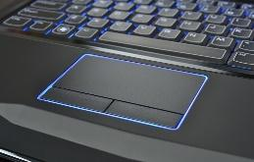
You can disable your laptop’s mouse touchpad whenever you have an external mouse connected to your computer. Select “Settings” under the Start Menu, then select “Devices (Bluetooth, printers, mouse)”. Click on “Mouse & touchpad.” Scroll down, and you will see “Leave touchpad on when a mouse is connected.” Click to turn this option OFF.

